**Project Title- GATE_JOB Website**

**Description-**

**We are developing a website for helping the students of our college in their preparation for GATE exam or a JOB.**

**In this website they can get access to the best available materials for their preparation in one platform. All they need to do is just choose their learning path (GATE or JOB or BOTH).**

**The roadmap for their preparation will be created automatically according to their choice and there year of study.**

**We will also include a live streaming section for the teachers so that they can take classes online and provide their materials in this platform. And any student can access the classes whenever they needed.**

**There will be a section for online examination also.**

**And we are planning to make a plagiarism detector using image processing.**

**Best Features –**

**1.User Friendly Platform (easy to use),**

**2.Rank or Score Predictor,**

**3.Voice assistant,**

**4.Live Classes,**

**5.Online test section.**

**Progress**

**Till date we have completed the basic website designing part, we have designed the basic predictor, the voice assistant and we are working on the live streaming part**

**I am attaching the screenshots of our work.**

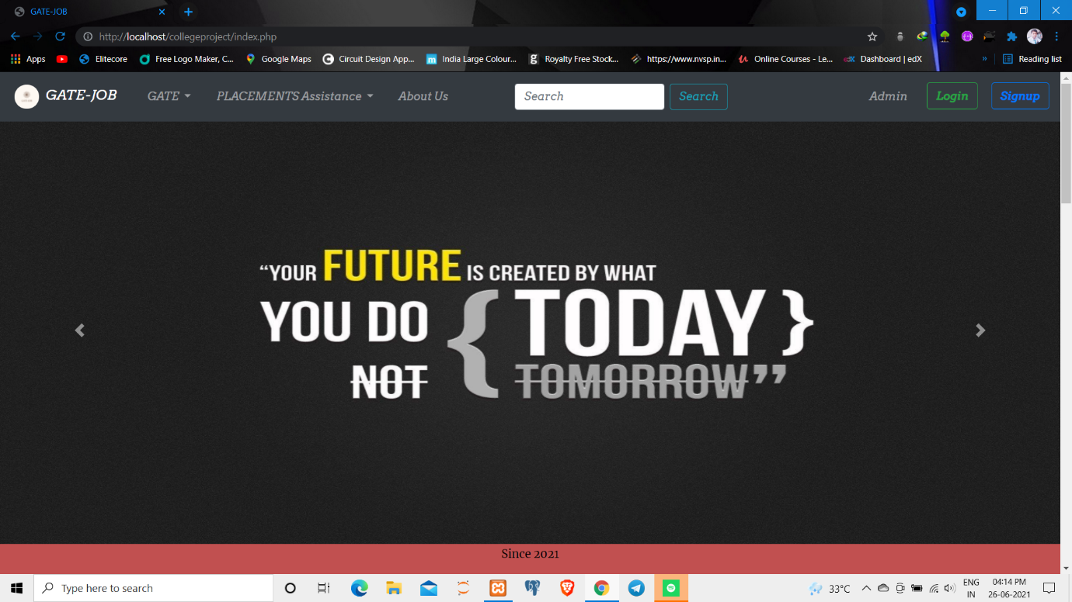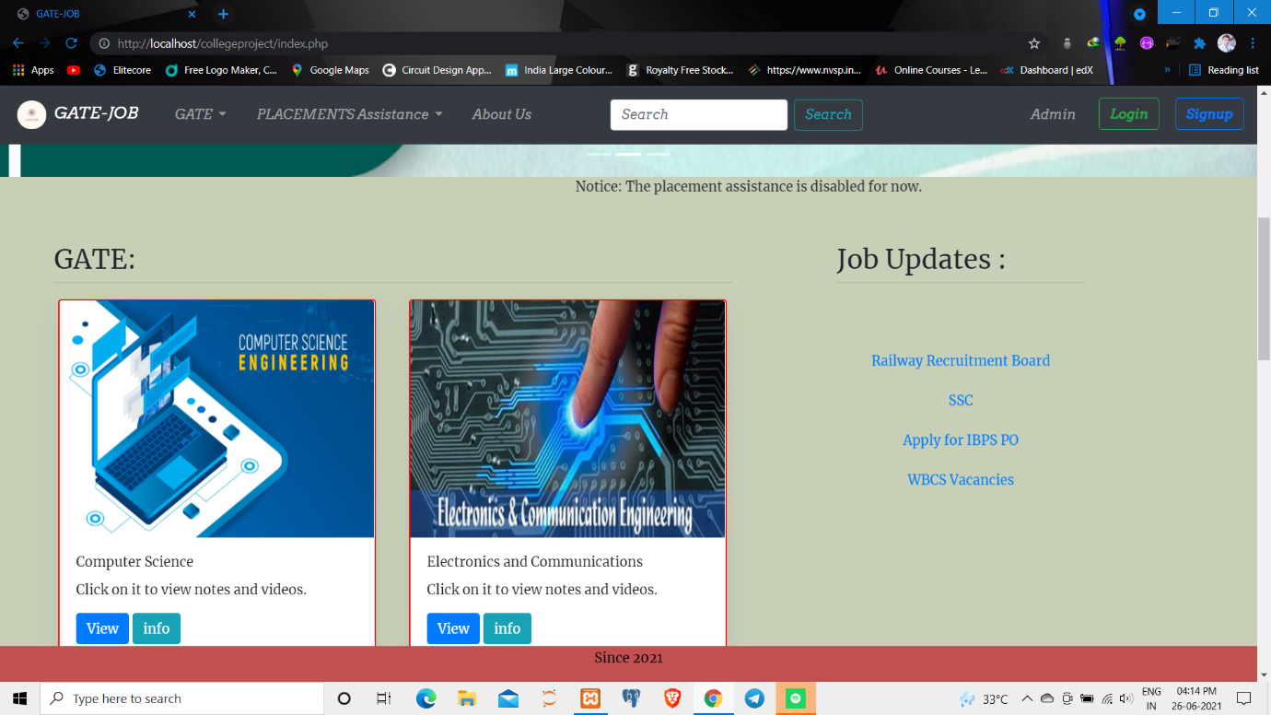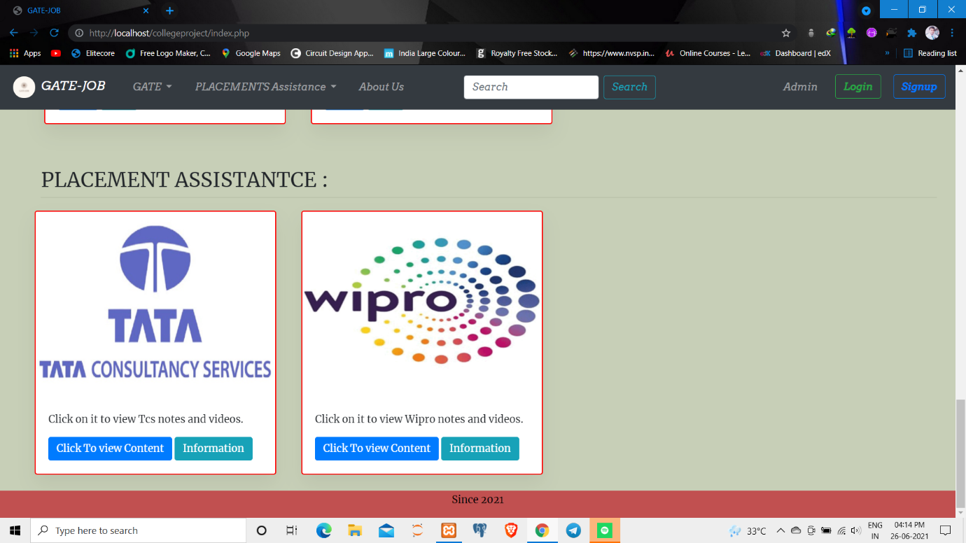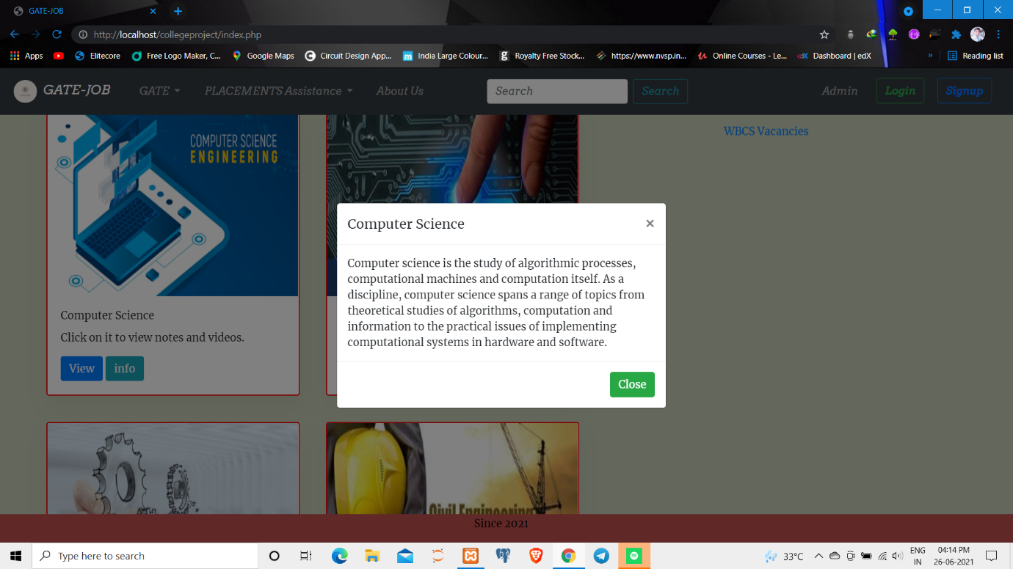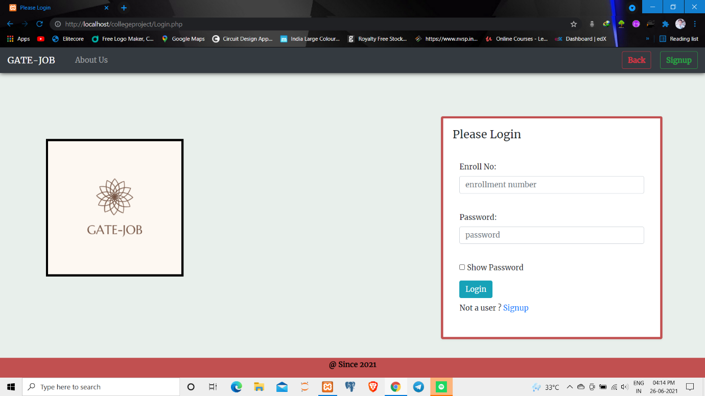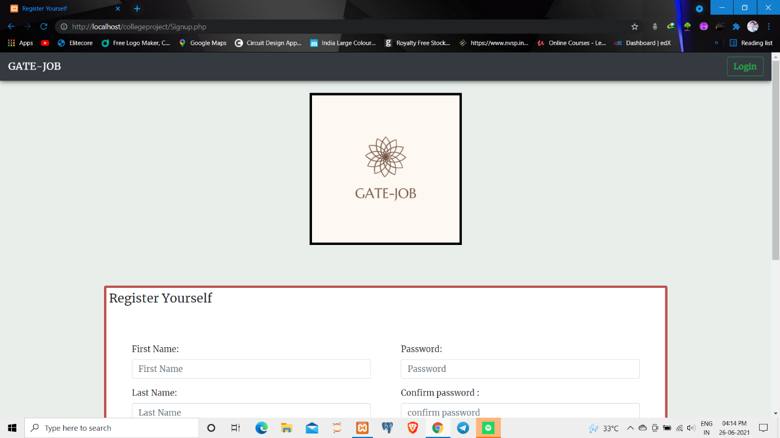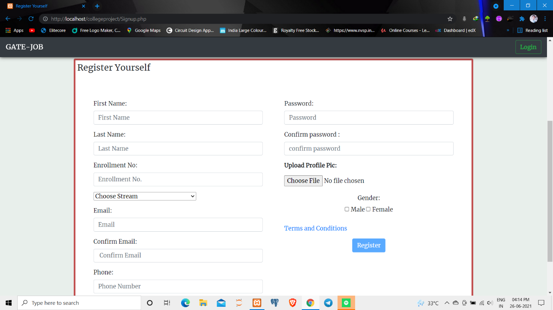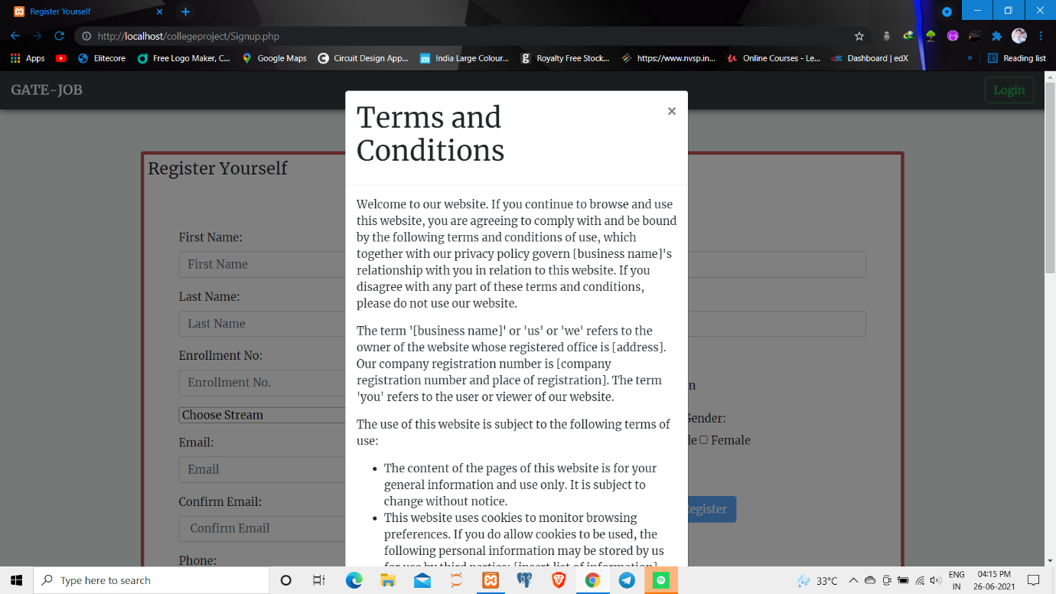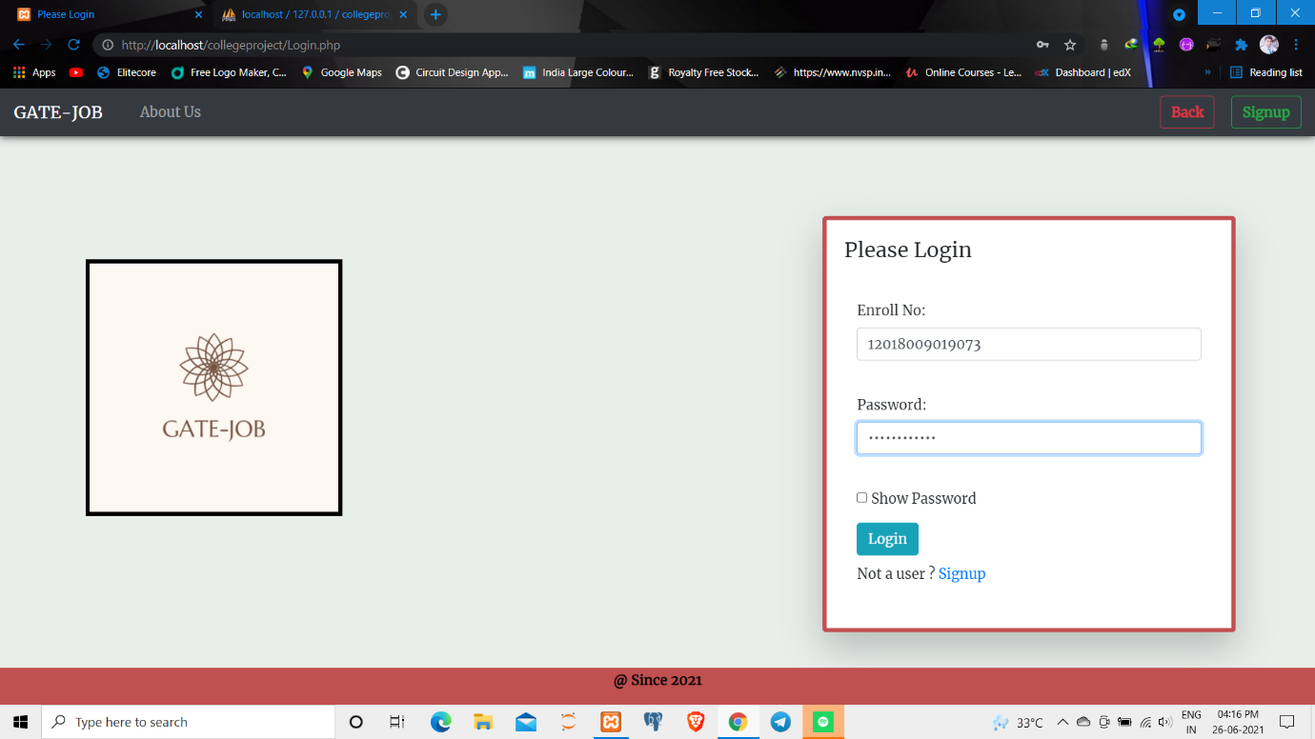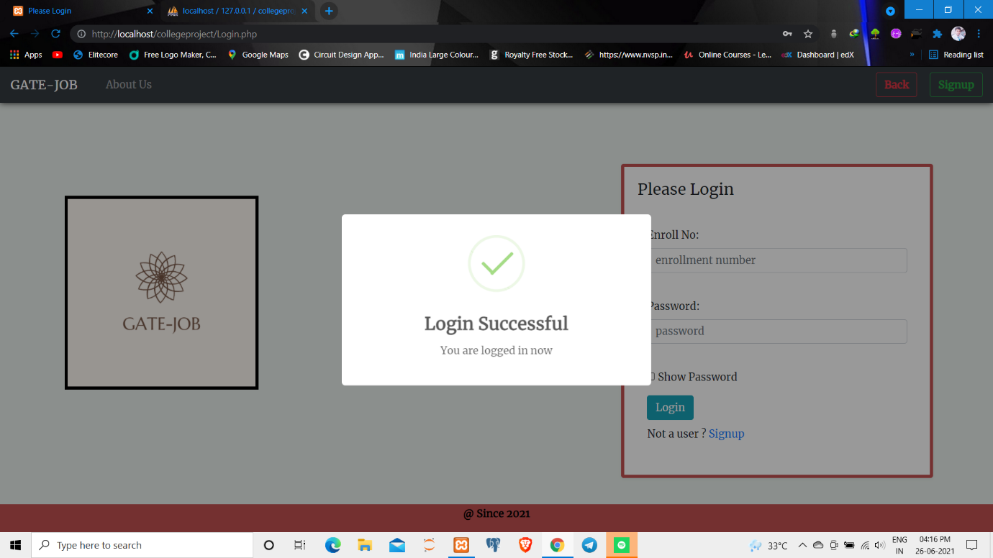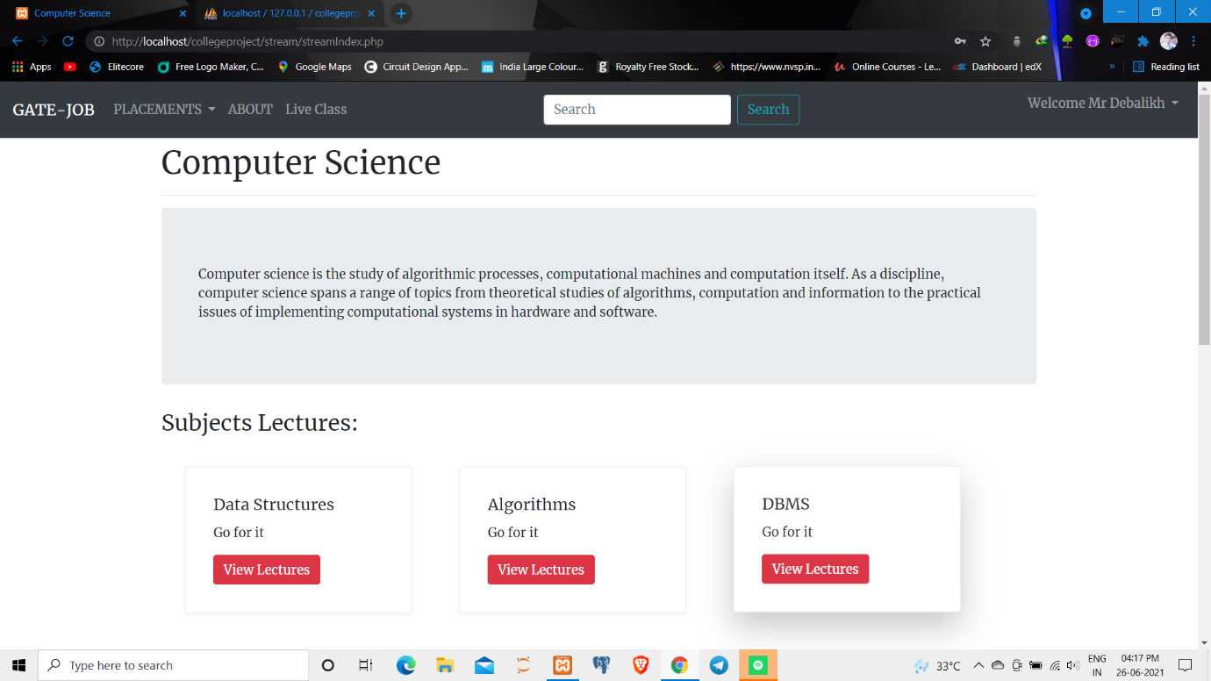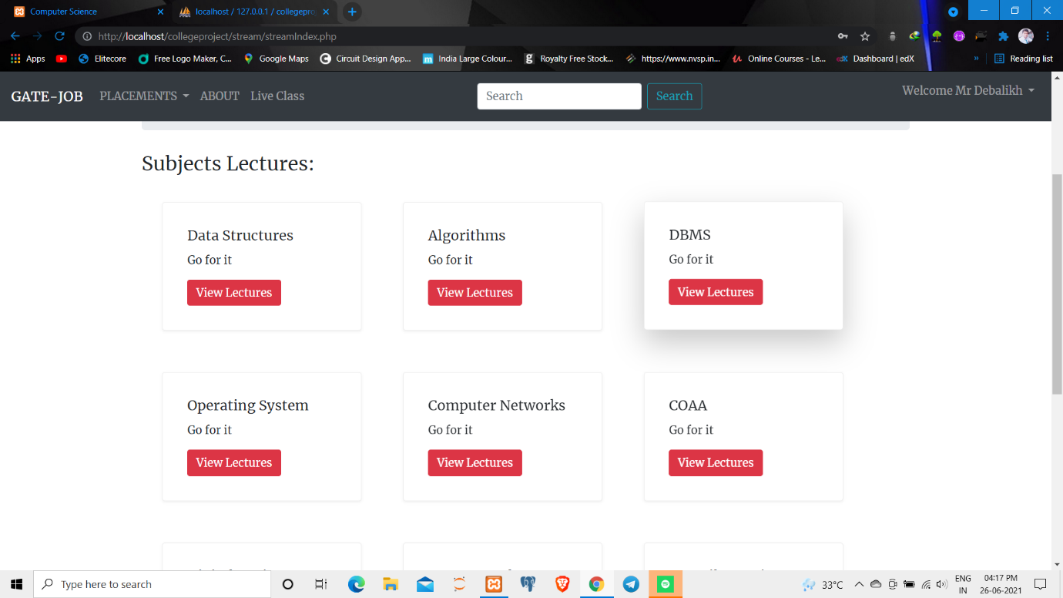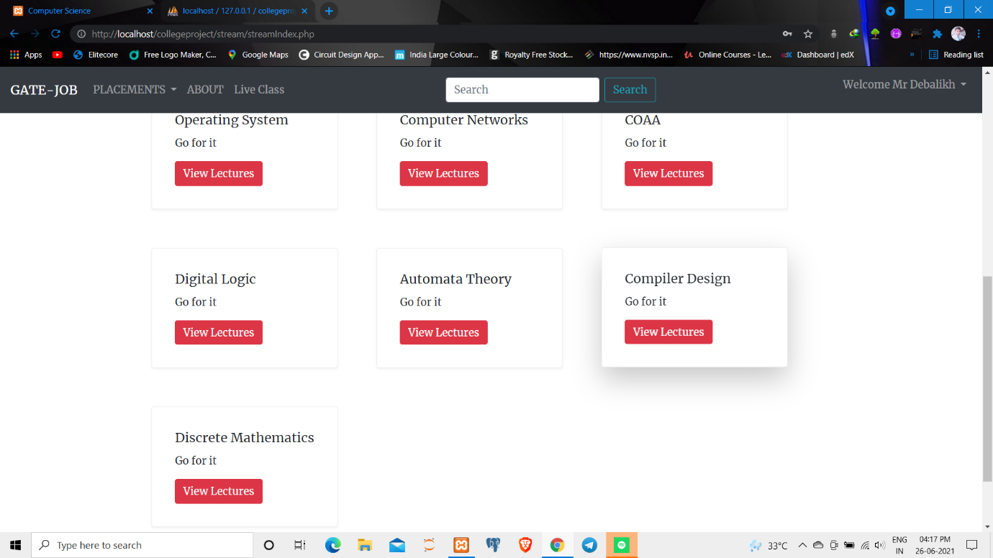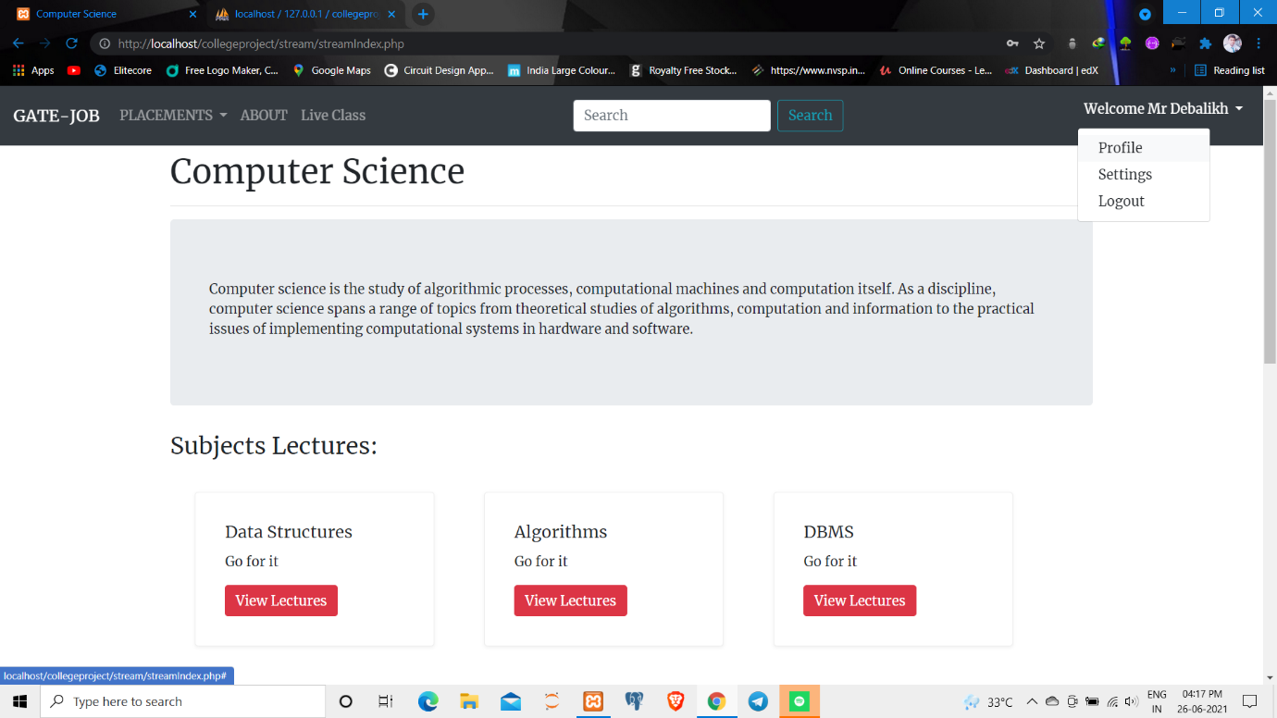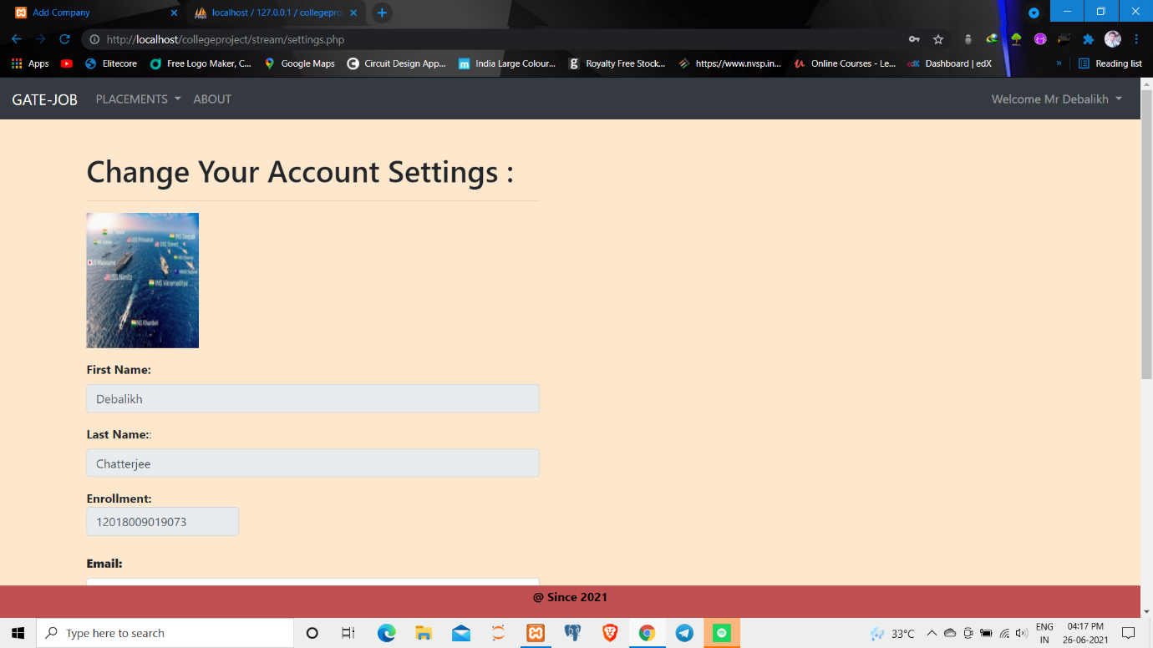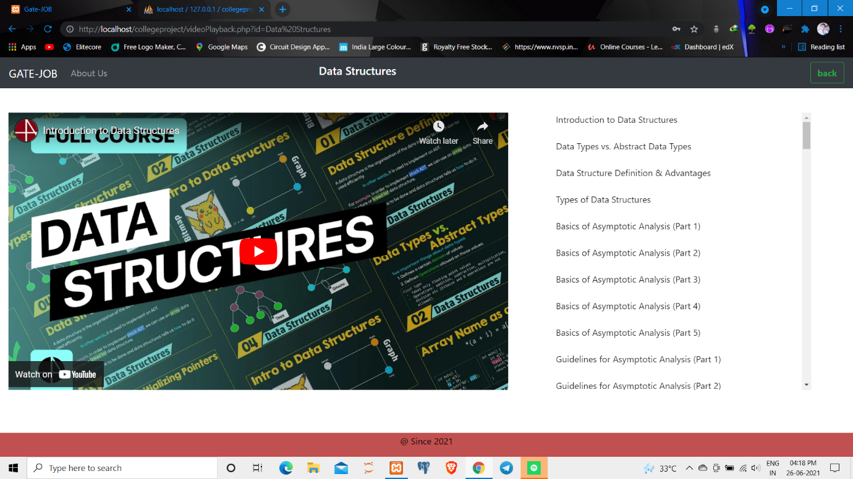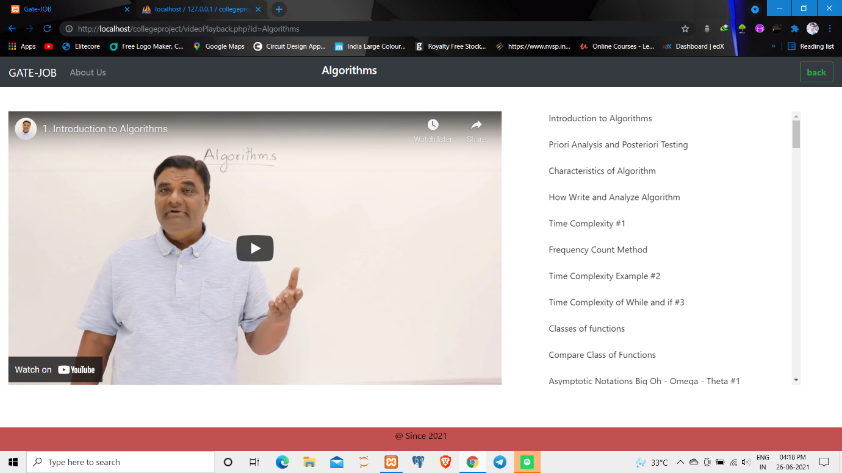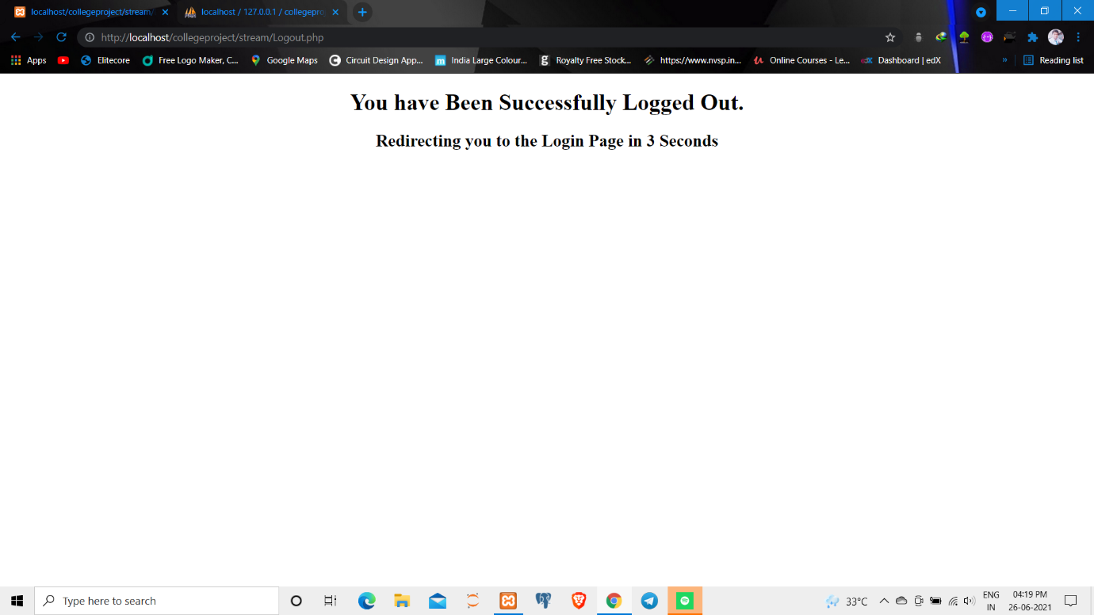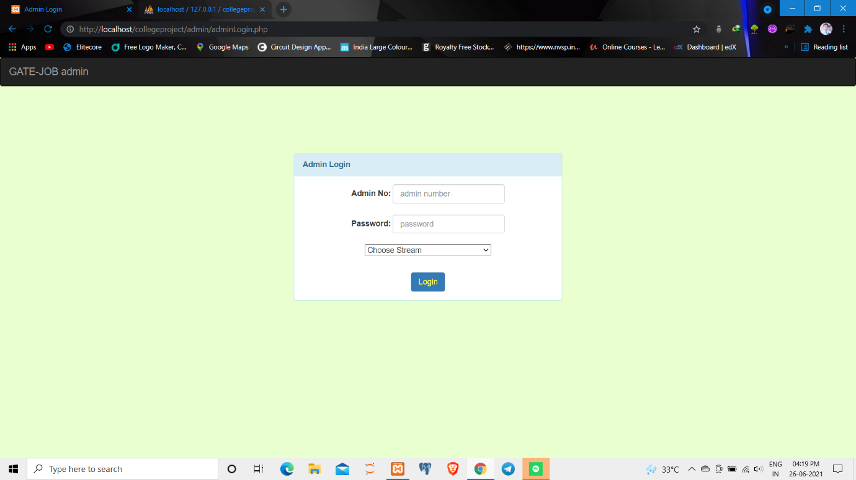

LIVESTREAM part

